Quarter 3 Year: 2023-2024 Course Code: CSE 202
Student’s Full Name: Student ID:
Date: May 21, 2024 Signature:

* Students are allowed to use a handwritten A4 sheet
1. Provide the definitions of the following concepts (20đ).
- Tree
- Complete graph
- Bipartite graph
- Leaf (in tree)
- Balance tree
2. Prove that a graph with at least 3 vertices of odd degree does not contain a Euler path (10đ)

3. Prove that in a full binary tree, the number of leaves equals to the number of internal vertices + 1 (10đ)
4. Traverse the following binary tree and print node’s labels with pre-order, in-order, and post-order: (15đ)
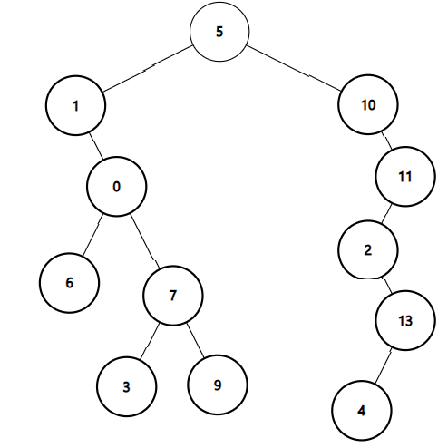
In-order:
Pre-order:
Post-order:

5. Construct the binary tree from given Inorder and PostOrder traversals (10 đ)
In-order: 12 1 11 7 8 0 6 10 9 2 4 5 3
Post-order: 12 11 8 7 1 10 9 6 5 3 4 2 0

Các bạn làm câu bài tập sau
6. Print the lexicographically largest DFS and BFS traversals of the graph starting from 6. (10đ)
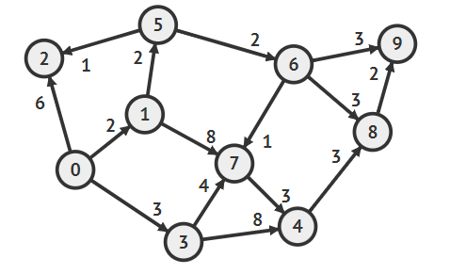
- DFS 6 9 7 8 3 4 1 5 0 2
- BFS 6 9 8 7 4
7. Draw the binary search tree if its nodes are inserted in the following order (15đ):
31, 20, 72, 96, 76, 13, 18, 78, 98, 26, 94, 97, 80, 1, 83, 38, 86

